Product Description

1. Obdstar ODO Master is a new Android based 5'' tablet, specialized for cluster calibration.
2. The device inherits the latest cluster calibration technology from OBDSTAR with various advantages of easy-to-use, wide model coverage, fast operation and durable features which can meet the actual needs of different users such as automobile repair plants and fast repair shops.

**OBDSTAR ODO Master X300M+ for Odometer Adjustment/OBDII and Oil Reset Functions**

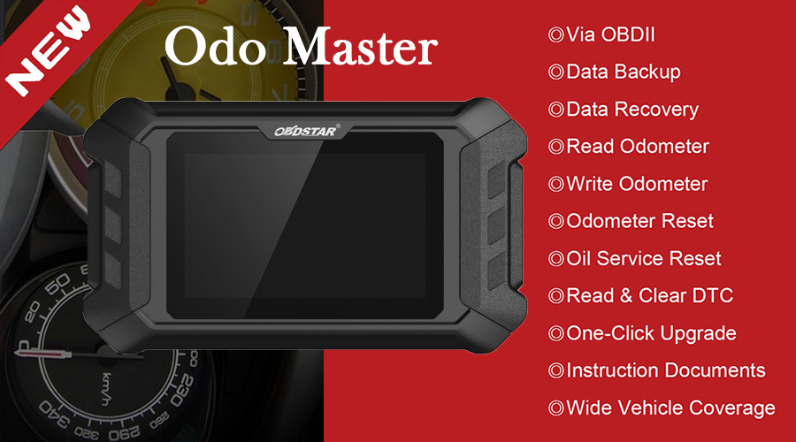  
  
**OBDSTAR ODO Master Highlights:**  
   
1. The update cycle is short and fast (updated every 2-3 days)  
2. Free Update Online for One Year. After one year it will cost $199 per year. Check [**OBDSTAR ODO Master Update Service**](https://www.uobdii.com/wholesale/obdstar-odo-master-one-year-update-service.html)  
3. Strong competitiveness and industry advantage  
4. Some models can support 20/21 years of car (such as GM/Chrysler)  
5. Multi-Language: English, Italian, Russian, German, Spanish, Polish, Portuguese, French (Default language is English, please pass us serial number to change)  
6. Add a new help function as shown below: (Applicable to some models, R & D information is being update)  
7. If you also need Airbag Reset function, you can buy the [**authorization and adapter**](https://www.uobdii.com/wholesale/obdstar-airbag-reset-kit-and-authorization.html) to get the same function as the [**OBDSTAR P50**](https://www.uobdii.com/wholesale/obdstar-p50-airbag-reset-tool.html).  
  
**Notice:**  
If you had an OBDSTAR device and registered before, when you register a new OBDSTAR machine, please change another email.   
  
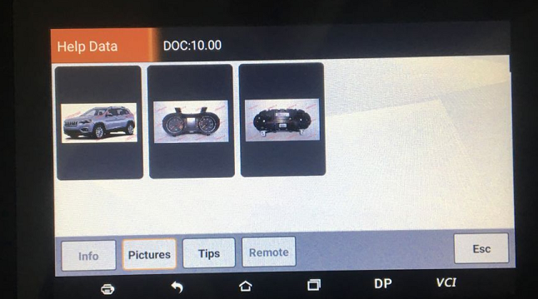  
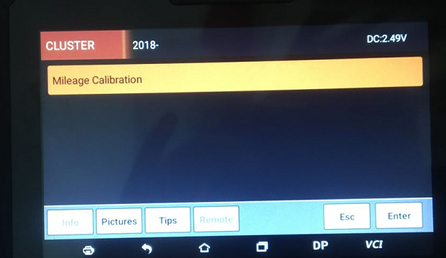  
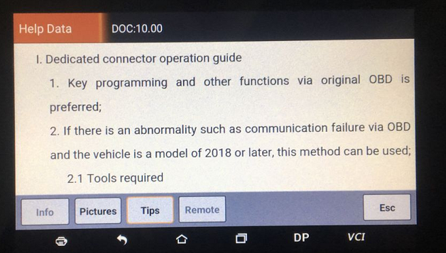  
  
**OBDSTAR ODO Master Functions List:**  
   
1. Via OBDII  
2. Data Backup  
3. Data Recovery  
4. Read Odometer  
5. Write Odometer  
6. Odometer Reset  
7. Oil Service Reset  
8. Read & Clear DTC  
9. One-Click Upgrade  
10. Instruction Documents  
11. Wide Vehicle Coverage  
  
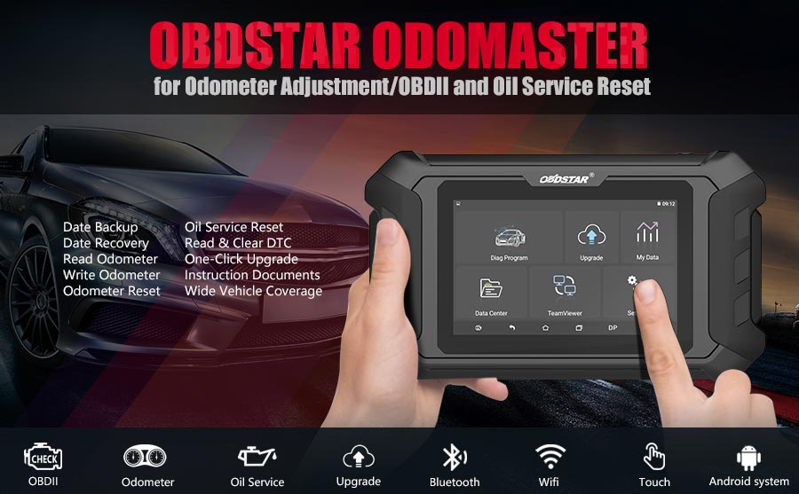  
  
**OBDSTAR ODO Master Support Car Software list:  
  
Europe:**  
ALFA ROMEO,AUDI,BENTLEY,BENZ,BMW/Mini,CITROEN,PEUGEOT,FERRARI,FLAT,JAGUAR,LANCIA,LAND ROVER,MASERATI,OPEL,PORSCHE,RENAULT,VOLVO,IVECO,SKODA,SEAT,VW  
  
**Japan:**  
ISUZU,MAZDA,MITSUBISHI,INFINITE,NISSAN,SUBARU,TOYOTA  
  
**Korea:**  
HYUNDAI,KIA,SANGYONG  
  
**America:**  
FORD/LINCOLN,CHRYSLER,GM  
  
**China:**  
GEELY,BESTURN,CHANGAN,ROEWE MG,ROEWE

**OBDSTAR ODO Master New Car Models Coveraged Comparison with**[**OBDSTAR X300M**](https://www.uobdii.com/wholesale/obdstar-x300m-for-odometer-adjustment-and-obdii.html)**:**

|  |  |  |  |
| --- | --- | --- | --- |
| Car Models Coveraged | | ODO Master | X300M |
| Ford | Fiesta | 2017- | 2013- |
| Focus | 2019 | 2013- |
| Transit | √ | × |
| KA | 2018- | 2005- |
| GM | Colorado | 2018- | 2010- |
| Cruze | 2017- | 2015- |
| Escalade | 2018- | / |
| XT6 | 2019 |  |
| Yukon | 2017- | 2014- |
| Chrysler | Cherokee | 2018- | 2015 |
| RAM | 2018- | 2011- |
| Durango | 2018- | 2014- |
| Land Rover | Discovery 4 | 2015- | / |
| Range Rover Sport | 2017- | 2014 |
| VW | MQB 2012-2014.06 | √ | × |
| MQB 2014.06- | √ | √ |
| Renault | Captur | 2017- | / |
| Trafic IV | 2017- | / |
| KIA CEED | 24C16 | √ | √ |
| D70F3423 | √ | √ |
| D70F3XXX | √ | × |
| D70F3421 | √ | × |
| D70F35XX | √ | × |
| NEC | √ | × |
| NEC+24C16 | √ | × |
| KIA Optima | 24C16 | √ | √ |
| D70F3536 | √ | √ |
| D70F3421 | √ | × |
| D70F352X | √ | × |
| D70F35XX | √ | × |
| NEC | √ | × |
| NEC+24C16 | √ | × |
| Nissan | Altima 2013 | √ | √ |
| KICKS 2017- | √ | × |
| Mitsubishi | Outlander | √ | × |
| Triton 2015- | √ | × |

**OBDSTAR ODO Master Hardware Comparison with**[**OBDSTAR X300M**](https://www.uobdii.com/wholesale/obdstar-x300m-for-odometer-adjustment-and-obdii.html)**:  
  
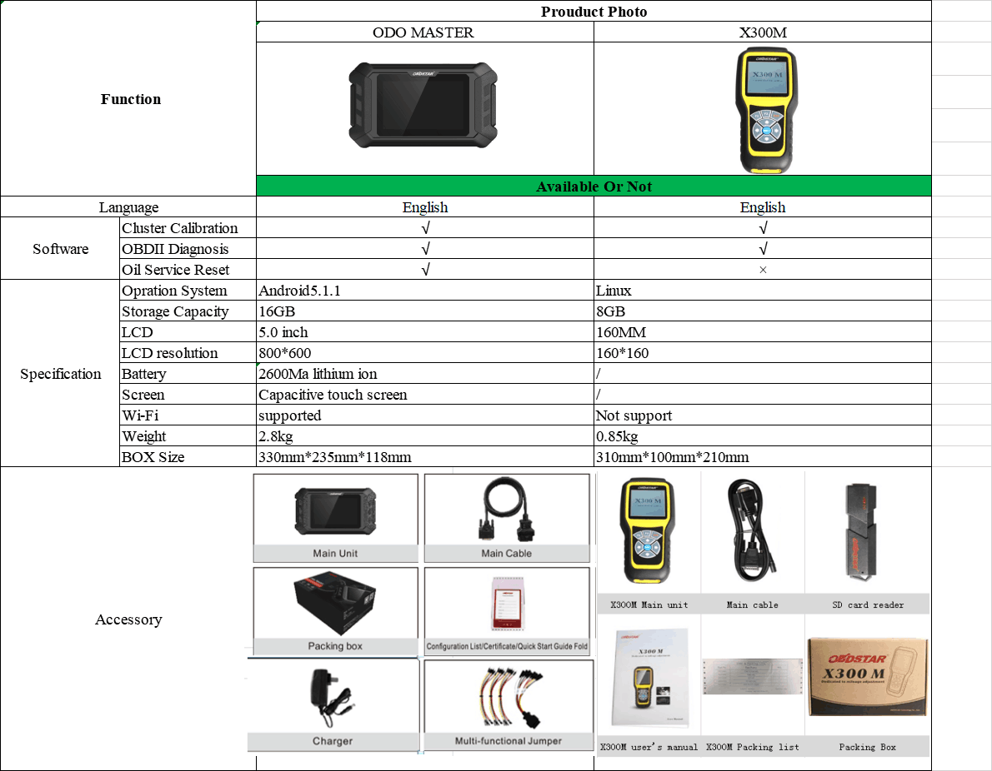  
  
OBDSTAR ODO Master Specifications:**

|  |  |
| --- | --- |
| Operation System | Android 5.1.1 |
| CPU | RK3128 Quad-Core ARM Cortex A7 1.2GHz |
| Battery | 2600mA, rechargeable polymer lithium battery |
| Extension Memory Card | 32G Micro SD (TF) card supported |
| Memory Capacity | 16GB |
| Storage Capacity | 32GB |
| LCD | 5.0 inch |
| LCD Resolution | 8000*600 |
| Touch Screen | Capacitive touch screen |
| Camera | 5 mega rear view camera |
| Wi-Fi | supported |
| Working Temperature | -20℃ ~ 55℃（14℉ ~ 131℉） |
| Storage Temperature | -20℃ ~ 70℃（-4℉ ~ 158℉） |
| Dimension | 140mm*89*mm*18mm |
| Weight | About 700g |

**OBDSTAR ODO Master Package includes:**

1pc x OBDSTAR ODO Master Main Unit

1pc x Charger

1pc x Multi-functional Jumper  
1pc x Configuration List

1pc x Packing box